**Finite Element methods**

**Mini-Project REPORT**

**on**

**Implosion Analysis:**

**A Case study on**

**‘OceanGate’s Titan Submarine’**

by

**Manudev Verma**

**(Registration No – 20226082)**

**BTech VI Semester (Mechanical Engineering)**

A project report submitted

in partial fulfilment of the requirements for the course of

**Finite Element Methods**

**Submitted to**

**Department of Mechanical Engineering**



**Motilal Nehru National Institute of Technology Allahabad**

**Prayagraj, UP, India, 211004**

1 June, 2025

# DECLARATION

I **Manudev Verma** hereby declare that this FEM Poject report titled “*Implosion Analysis: A Case study on ‘OceanGate’s Titan Submarine’* ” is wholly my own work and has not been submitted anywhere else for academic credit, either by myself or another person.

I understand what plagiarism implies and declare that this project report embodies my own ideas, words, phrases, arguments, graphics, figures, results and organization except where reference is explicitly made to another work.

I understand further that any unethical academic behaviour, which includes plagiarism, is seen in a serious light by MNNIT Allahabad and is punishable by disciplinary action as stipulated by the institute’s rules and regulations.

**Date – 1st June, 2025 Name – Manudev Verma**

**Place – Prayagraj Reg No. No: 20226082**

# 

# ACKNOWLEDGEMENTS

I would like to express my sincere gratitude towards Course Coordinator Prof Mukul Shukla, for their invaluable guidance and support in uplifting the quality of my Project and compile a standard report. Their expertise and insights have significantly contributed to the success of this project and report.

I am also grateful to my classmates and friends who provided encouragement and assistance during the presentation preparation.

In conclusion, I am thankful to everyone who directly or indirectly contributed to the completion of this presentation report. Their support has been invaluable, and I am deeply appreciative of their efforts.

**Date Manudev Verma**

1st June, 2025

**ABSTRACT**

In this report a study on Implosion analysis of OceanGate’s Titan Submarine is presented. This report investigates the design, operational history, and catastrophic failure of OceanGate Inc.’s *Titan* submersible, which imploded during a descent to the Titanic wreck site on June 18, 2023, resulting in the loss of all five occupants. Designed with a **Carbon-Fiber Composite Hull** and an **Acrylic Viewport**, *Titan* deviated significantly from conventional submersible engineering standards, which typically favour metallic pressure vessels and certified components. Despite repeated warnings from industry experts and former employees about its structural integrity and lack of regulatory oversight, OceanGate proceeded with deep-sea missions without third-party classification or full-scale testing under sustained pressures.

On its final dive, communication with the surface vessel was lost approximately **1 hour and 45 minutes** after launch. Days later, a debris field consistent with a high-energy implosion was located near the Titanic site. Subsequent investigations and acoustic data from the U.S. Navy confirmed a rapid structural collapse.

The likely sequence of failure is hypothesized to begin with the rupture of the forward-facing acrylic viewport, which was reportedly rated for significantly shallower depths. This localized breach may have initiated a cascading failure, causing the surrounding carbon-fibre hull to implode under external pressures exceeding 38 MPa.

A finite element simulation using ANSYS Explicit Dynamics (detailed in the full report) was conducted to replicate these conditions. The results support the failure hypothesis**: initial pressure-induced fracture of the viewport followed by complete structural failure of the hull within milliseconds**. This tragic event underscores the critical importance of engineering validation, rigorous material testing, and adherence to established safety standards in manned deep-sea exploration.

**TABLE OF CONTENTS**

*DECLARATION 1*

*ACKNOWLEDGEMENTS 2*

*ABSTRACT* ***Error! Bookmark not defined.***

Chapter 1: INTRODUCTION 5

1.1. Introduction 5

1.2. Background of OceanGate and Titan Submersible 6

1.3. Overview of the June 2023 Tragedy…………………………………………………6

1.4. Likely cause of Disaster: Structural and Material Concern ……………………..…...7

CHAPTER 2: Finite Element Analysis

2.1. Pre-Processing:

2.1.1. Material Selection + Failure Criteria 9

2.1.2. Geometry Selection ………………...…………………………………………..9

2.1.3. Meshing...…………………………………………………………...…………11

2.1.4. Boundary Conditions…………………………………………………………..12

2.2. Processing

2.3. Post-Processing

2.3.1. Total Deformation………….………………………………………………….14

2.3.2. Von Misses Stress…………………………………………….………………..15

2.3.3. Von Misses Strain………………………………………………………..…….15

2.3.4. Energy Plot…………………………………………………………………….16

2.3.5. Momentum Summary………………………………………………………….16

Chapter 3: CONCLUSIONS .

3.1. Conclusions. 17

REFERENCES 14

# CHAPTER 1

# INTRODUCTION

_________________________________________________________________________

* 1. **Introduction:**

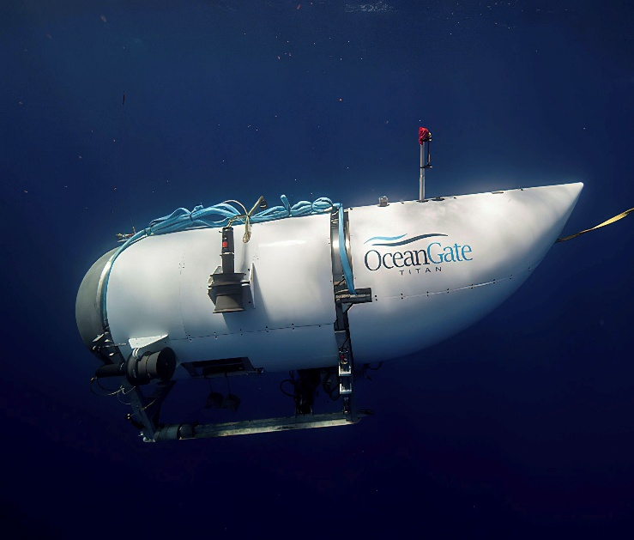This document presents a thorough overview of OceanGate’s Titan submersible, covering its development timeline, the events that culminated in the fatal accident in June 2023, and an engineering analysis of potential causes. Additionally, a designated section is provided for the insertion of results from a finite element simulation using ANSYS Explicit Dynamics, which aims to replicate the conditions and failure progression experienced by the Titan during its final dive.

* 1. **Background of OceanGate and Titan Submersible:**

**OceanGate Inc.**, established in 2009 by Stockton Rush and Guillermo Söhnlein, set out to revolutionize deep-sea exploration by creating submersibles capable of reaching extreme depths. Operating from Everett, Washington, the company focused on designing manned underwater vehicles to access parts of the ocean previously considered unreachable.

* **2009–2017**: The firm initially deployed two submersibles, Antipodes and Cyclops 1, for relatively shallow operations (depths up to 500 meters).
* **2018**: Titan—initially named Cyclops 2—was introduced as an advanced, carbon-fiber and titanium hybrid vessel engineered to dive as deep as 4,000 meters, specifically for Titanic site missions.
* **2021**: The company launched its first commercial dives to the Titanic wreck, catering to researchers and paying guests.
* **2021–2023**: Multiple expeditions were completed, although several dives were cut short due to technical issues. Concerns about the vessel’s design and safety practices began surfacing in both internal reports and external expert commentary.
  1. **Overview of the June 2023 Tragedy:**
* Date of Incident: June 18, 2023
* Location: North Atlantic Ocean, approximately 370 nautical miles off Newfoundland, close to the Titanic wreck at a depth of around 3,800 meters
* Vessel Involved: Titan
* Crew and Passengers:
  + Stockton Rush (OceanGate Founder & CEO)
  + Hamish Harding (British adventurer and businessman)
  + Shahzada and Suleman Dawood (father and son from a prominent Pakistani-British family)
  + Paul-Henri Nargeolet (French Titanic researcher)

**Sequence of Events:**

* **June 18:**
  + 8:00 AM (EDT): Titan initiates its descent toward the Titanic site.
  + Roughly 9:45 AM: Last known communication received from the submersible.
  + By mid-afternoon, the support vessel *Polar Prince* reports a loss of contact and begins coordinating search efforts.
* **June 22:**
  + A remotely operated vehicle detects a debris field near the Titanic's bow, consistent with a catastrophic implosion.
  + The U.S. Navy later confirms it recorded an underwater acoustic anomaly on June 18, shortly after contact was lost, indicative of a sudden hull collapse.
  1. **Likely Cause Of Disaster:**

**1.4.1 Structural and Material Concerns**

* **Unconventional Hull Design**: Titan’s hull was primarily constructed from carbon fiber, an unusual choice for deep-sea vehicles that are typically built with steel or titanium. This raised questions about its behavior under repeated high-pressure cycles, particularly the risks of delamination and fatigue.
* **Inadequate Viewport**: The acrylic (plexiglass) viewport reportedly had a depth rating far below 3,800 meters. A breach in this component could have precipitated rapid structural failure.
* **Lack of Independent Certification**: The vessel did not undergo formal classification or certification by recognized marine engineering bodies, such as DNV or ABS, raising further questions about its readiness for deep-sea deployment.

**1.4.2 Warnings That Went Unheeded**

* In 2018, former OceanGate Director of Marine Operations, David Lochridge, flagged serious safety issues in a whistleblower complaint. His concerns included:
  + The viewport not being certified for Titanic-depth dives
  + Inadequate stress testing of critical parts
* Industry experts had also cautioned OceanGate about the use of experimental designs without proper third-party validation.

**1.4.3 Operational and Safety Gaps**

* The vessel relied on acoustic monitoring systems to detect early signs of material stress rather than conventional testing and failsafe mechanisms.
* It lacked redundant life support or escape protocols.
* Given the extreme depth of the operation, any emergency scenario left the crew with virtually no possibility of rescue.

# Chapter: 2

# Finite Element Analysis + Simulation

### 2.1 Pre-Processing:

Whole analysis is done in explicit dynamics and not on static structural. This is because implosion is a very rapid phenomenon and to capture it, we need to have very small-time steps for each cycle. Implicit dynamics could also be used but since it takes a lot of iterations to converge the result in each cycle that would be computationally costly! Whereas Explicit dynamics doesn’t need matrix updating in each iteration as it assumes stress equilibrium at each step hence it is less computationally costly. Hence, I have used explicit dynamics in this project.

This phase involves setting up the simulation environment before any computation begins and is given as:

***2.1.1 Geometry Creation / Import:***

Geometry is imported from GrabCAD website (referenced below) and its important parts like hull, hemispherical caps and plexiglass window with connector rings are used in the analysis.(**Only important features are used**)

***2.1.2 Material Property Assignment + Failure Criteria:***

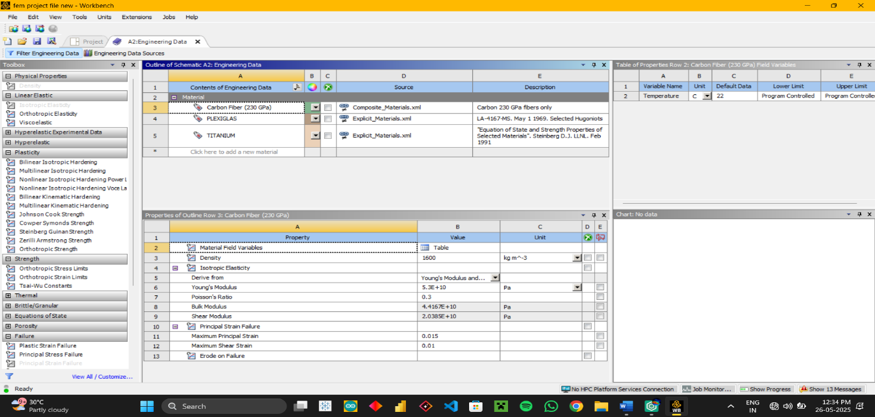**1.Crabon Fiber Reinforced Polymer:** The properties of CRRP(A composite material) is given below. Failure criteria used: ***Principle Strain Failure***:

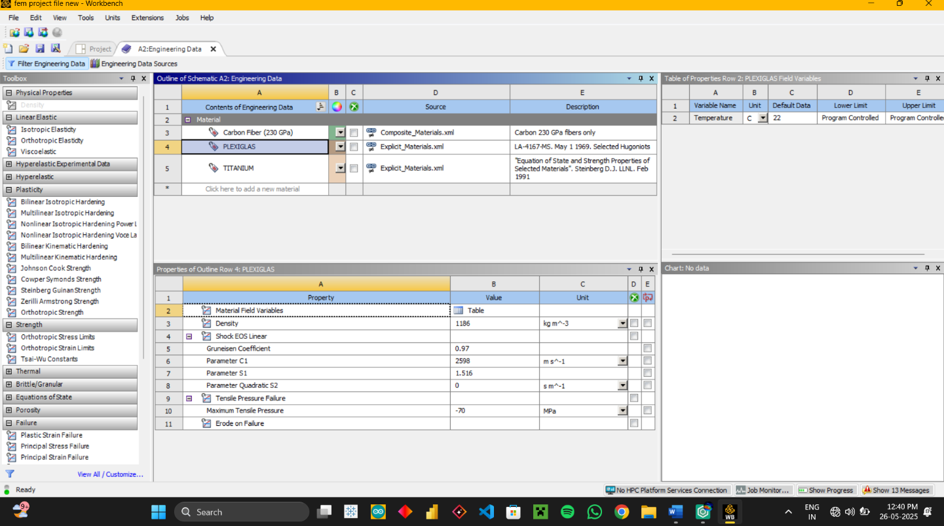 **2. Plexiglass:** The properties of plexiglass(a type of bristtle material, transparent in nature), used for view port in subarine is given below(Failue Criteria used: ***Tensile Pressure Failue***):

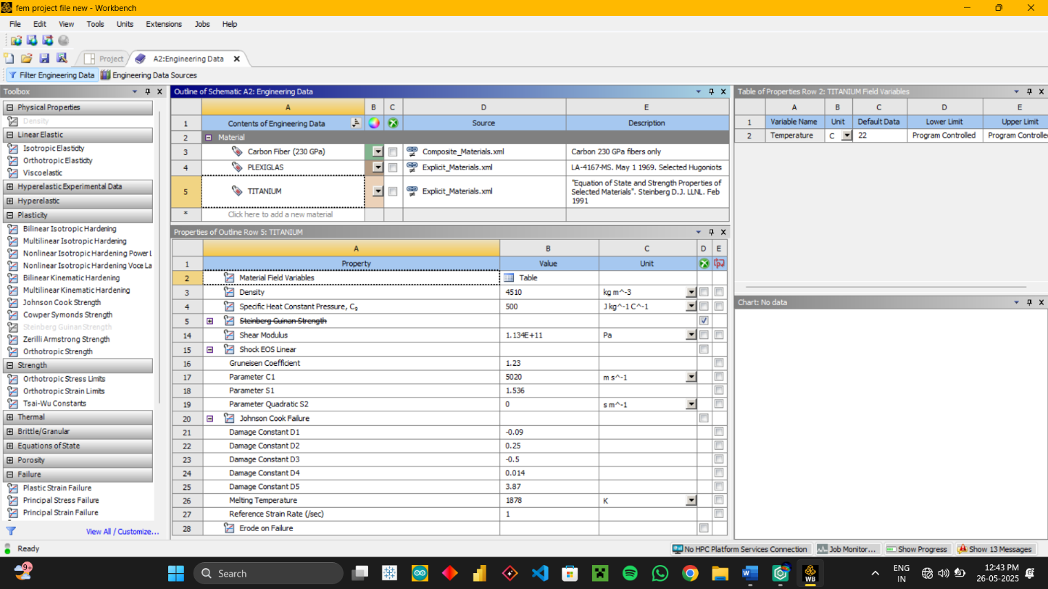**3. Titanium**: The properties of titanium is given below which is used to make the two strong heispherical domes(Failure Criteria used: ***Johnson Cook Fialue criteria***):

*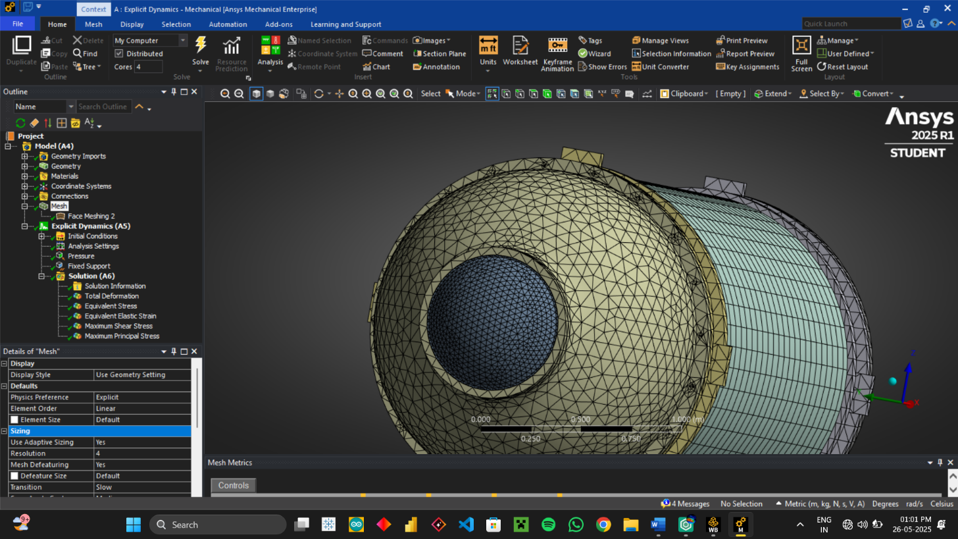****2.1.3 Meshing:*** Firstly Meshing is done by using generate mesh feature, then it is refinef in hull swection(Hex Element) and the window section by resolution of 4. Face meshing is applied onto the Hull section of the titan submarine, for better capturing of the implosion effect(**Total Elements: 71934**) :

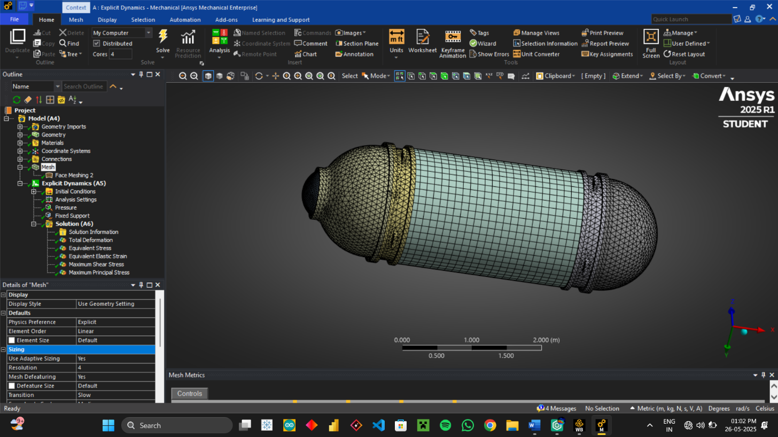

***2.1.4 Boundary Conditions:*** Boundary conditions are set as:

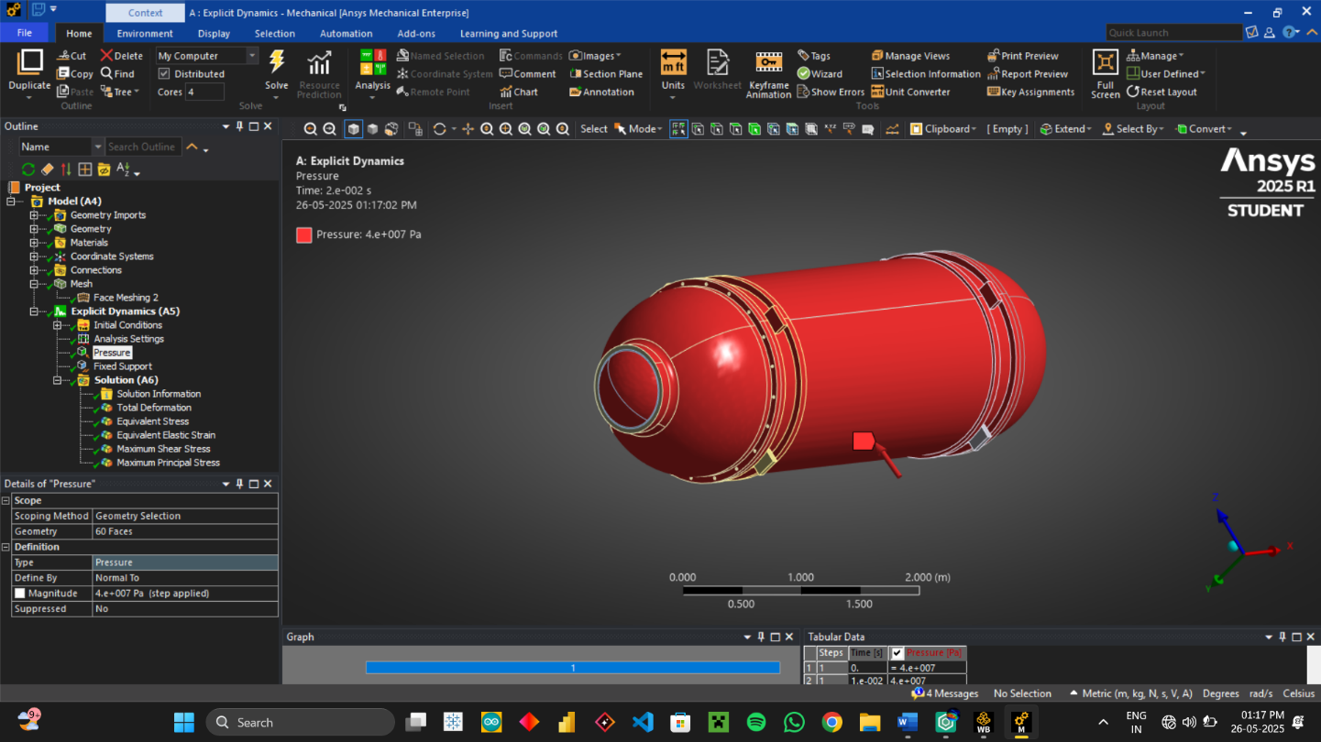1. **Pressure** = 40MPa since the implosion occurred at a depth of 3800 – 4000 meters under water so the pressure is applied all ove the outer surface of hull:

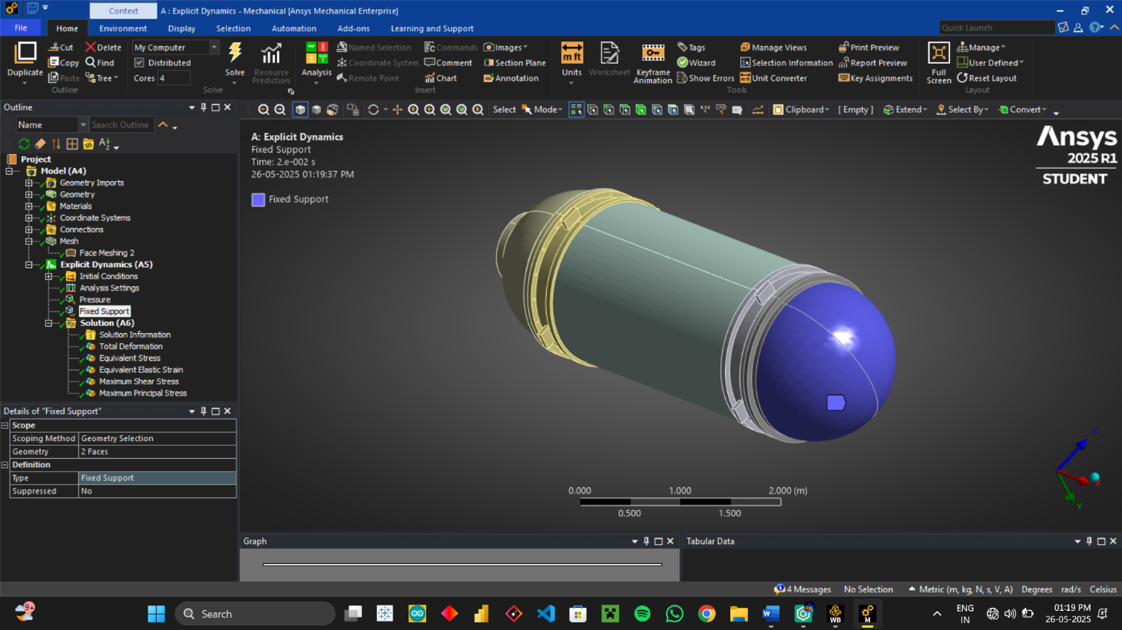2. **Fixed Support**: Fixed support is applied to the back titanium hemisphere, so as to remove any net movement of body in x direction during implosion:

### 2.2 Processing:

This is the computation stage where the simulation is executed based on pre-processing inputs.

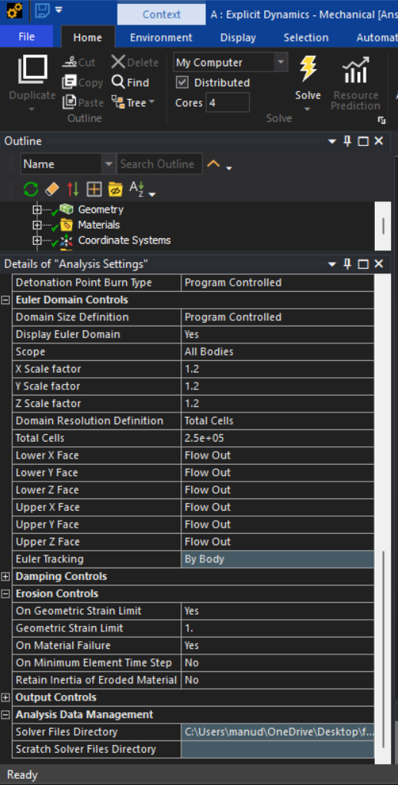***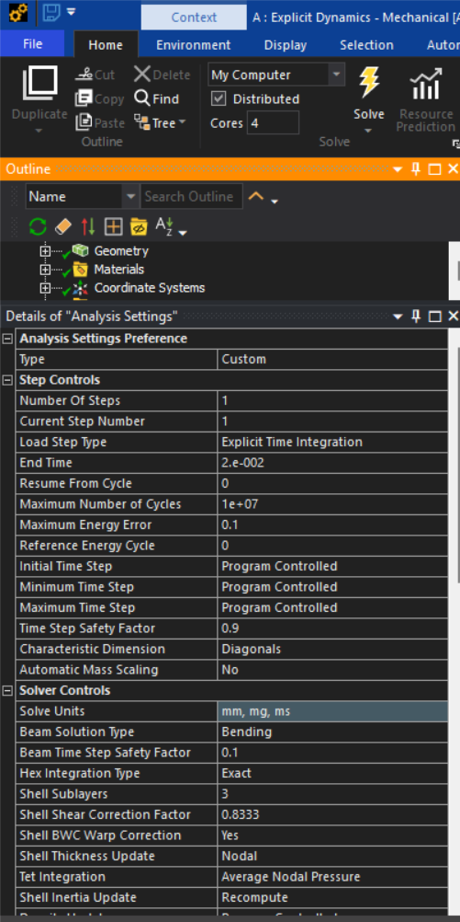2.2.1 Time Step Setup:*** The following setings are done by me for capturing extremly fast implosions in order of 3ms.

***2.2.2 Dynamic Loading Simulation:*** Solving the model using explicit dynamics, which took around 67 minutes to complete the analysis with 42572 number of cycles.

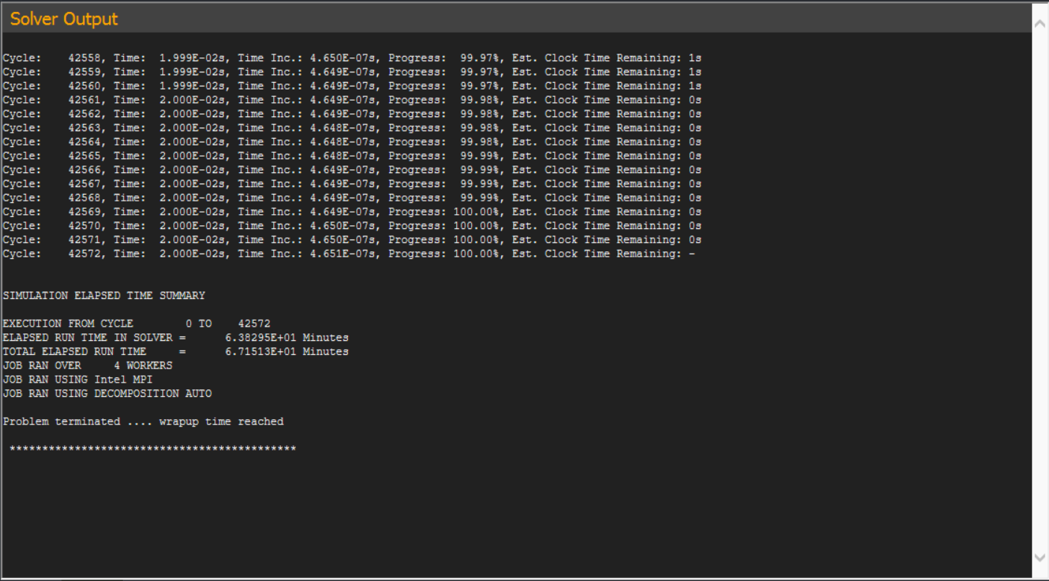

### 2.3 Post-Processing:

This stage involves analysing and interpreting the simulation output to draw engineering conclusions.

***2.3.1 Total Deformation Visualization:***

****Total deformation is visualized as:

***2.3.2 Equivalent Stress(Von Mises stress):***

Von Mises stress is visualized as: (Here the implosion is very rapid event(in milli seconds order) that’s why the stresses change rapidly during the implosion process in each cycle i.e. for almost 42500 times)

***2.3.3 Equivalent Strain(Von Mises strain):***

Von mises strain or equivalent strain is shown below it shows initial high strain rates at the viewport(plexiglass window) which caused it to break into pieces which became initiation point of the implosion:

***2.3.4 Energy plots:***

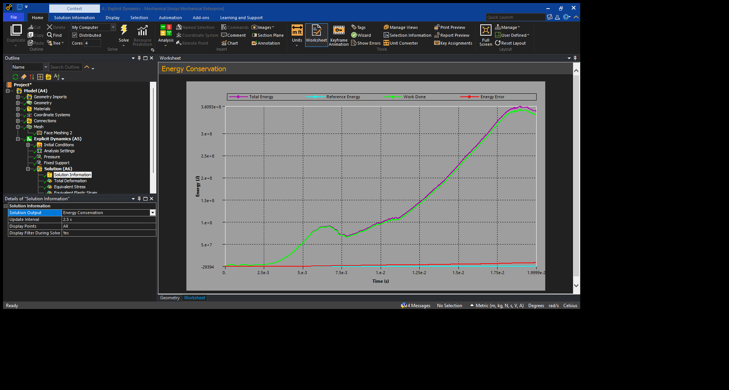a). **Energy Conservation Plot:** Here there is a small energy error at the last which has also occurred due to implosion and loss of element but overall, the project simulation is close to physical correctness.

***2.3.5 Momentum Summary:***

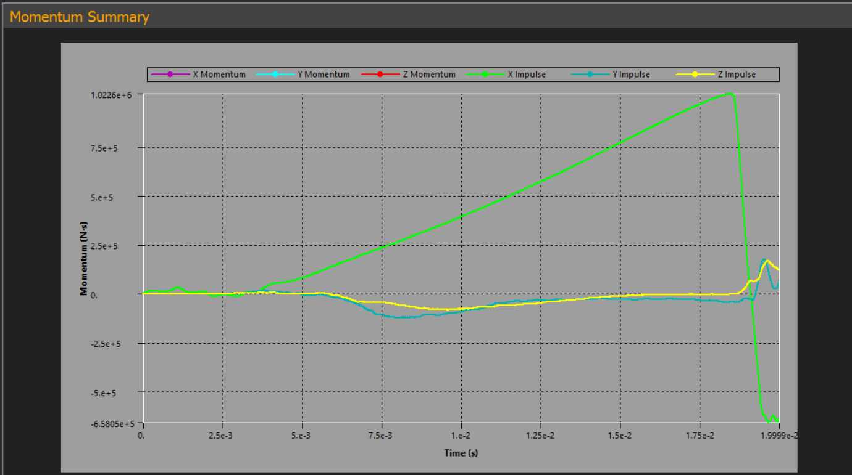The momentum summary shows that initially there is almost no motion but after collapse the titanium hemisphere moves in x direction due to extreme pressure differential inside.

# Chapter 3:

# CONCLUSION

The finite element analysis performed on OceanGate’s Titan submersible offers a detailed look at the sequence of structural failures that likely led to its implosion. Using an explicit dynamics approach over 42,567 cycles, the simulation revealed that the failure began at the viewport—where stress concentrations exceeded material limits well before the rest of the vessel. The viewport’s failure under intense hydrostatic pressure created a sudden loss of equilibrium, triggering a violent redistribution of forces throughout the hull.

What followed was a rapid chain reaction. As internal pressure equalized with the surrounding ocean, the composite hull lost its ability to resist external loads. Buckling patterns emerged almost instantly, especially around seams and joints, leading to a total collapse. The hull crumpled under the weight of the deep-sea pressure, with stress plots and energy curves confirming a sharp and irreversible failure shortly after the initial breach.

Throughout the simulation, stress levels fluctuated dynamically, capturing the complex and transient nature of the implosion. Localized yielding, plastic deformation, and eventual material erosion were all evident, highlighting how quickly structural integrity was lost once the failure began.

This analysis not only underscores the critical role of design margins around high-stress areas like viewports but also demonstrates the power of explicit dynamics in modelling rapid, high-energy failure events with precision.

## REFRENCES

*1.* [*https://grabcad.com/library/oceangate-s-titan-submergable-1*](https://grabcad.com/library/oceangate-s-titan-submergable-1)

*2. U.S. Coast Guard (2023) – Public Briefings and Reports*

*3. BBC News (2023) – “Timeline of the Titan Sub Incident”*

*4. Archived technical materials from OceanGate Inc.*

*5. Marine Engineering Codes – ASME, DNV Standards*

*6. ANSYS Documentation – Explicit Dynamics Analysis for High-Pressure Environments*

*7. YouTube explicit dynamics playlist/videos:*

*=>*[*https://www.youtube.com/watch?v=ARb4Pj6KAbk&list=PLR85MLhBo4KLyt1rH3t8cRyc4HIJ-z9XL&pp=0gcJCV8EOCosWNin*](https://www.youtube.com/watch?v=ARb4Pj6KAbk&list=PLR85MLhBo4KLyt1rH3t8cRyc4HIJ-z9XL&pp=0gcJCV8EOCosWNin)

*8. ChatGPT(For knowing more about explicit dynamics and its various options)*